Invitation: 8th International Week at PAAS, 20-24 May 2026

Dear Partners,
Just recently in May, Powiślańska Academy of Applied Sciences, Poland has held an International Week 2025, during which we hosted 50 participants from 34 HEIs, they came from 22 countries, from 4 continents.
This is a kind invitation for our next edition - 8th International Week 2026, which will be organized between 20-24th of May, 2026 (Wed-Sun format). We would love to see representative of our partner universities!

Dear Colleagues, Apply & Join!!
You have a chance to spend a week at Powiślańska Academy of Applied Sciences in Poland, who is organising it's 8th International Week between 20-24th of May 2026 in their branch in Gdańsk, Poland. The event is directed to the Academic Staff, as well as Administrative Staff.
Don't miss your chance, apply!
Program Details:
⏰ Duration: 20-24th of May, 2026
Location: Gdańsk, Poland
✅ Eligible Departments:
- Business Administration
- Economics
- Management
- Finance
- Accounting
- Nursing
- Emergency Medicine
- Midwifery
🔶 Participant's Benefits:
- Best practices in international teaching
- New methods of teaching
- Erasmus+ scholarship
- International Networking
- Explore Northern Poland
🔔 Application Deadline: 28th of February, 2026
📌 Registration form: https://forms.office.com/e/jwUX0pGVsC
We look forward to receiving your applications and welcoming you to this enriching Erasmus+ mobility experience at Powiślańska Academy of Applied Sciences. Should you have any queries or need further assistance, please feel free to reach out to us via erasmus@ powislanska.edu.pl

We would be grateful for the dissemination of the Call.
Best regards,

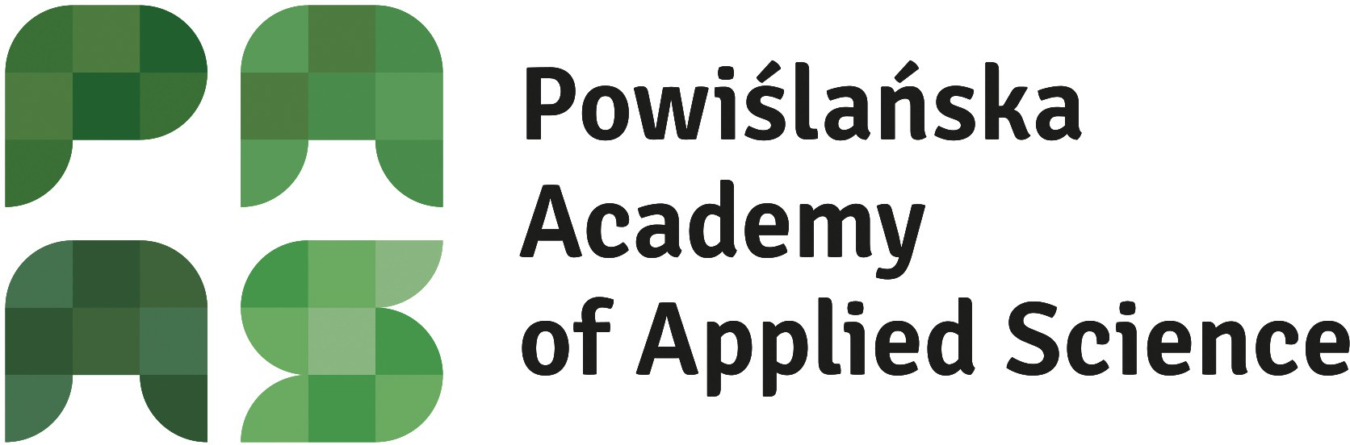
Powiślańska Academy of Applied Sciences 11 Listopada 29, 82-500 Kwidzyn
M. Smoluchowskiego 18, 80-214 Gdańsk

Włocławska 133, 87-100 Toruń
W. Sikorskiego 1, 83-400 Kościerzyna
Tel: +48 532 350 644
www.powislanska.edu.pl

